1).Write a JavaScript function that takes two numbers and an operator ('+', '-', '*', '/') as arguments

and returns the result of the arithmetic operation.

function addition(num1, num2) {

    return num1 + num2;

  }

  //By Values

  console.log(addition(5, 3));

  console.log(addition(10, 2));

  function subtraction(num1, num2) {

    return num1 - num2;

  }

  // BY values

  console.log(subtraction(10, 2));

  console.log(subtraction(6, 4));

  function multiplication(num1, num2) {

    return num1 * num2;

  }

  //by values

  console.log(multiplication(6, 4));

  console.log(multiplication(10, 2));

  function division(num1, num2) {

    return num1 / num2;

  }

  //by values

  console.log(division(10, 2));

  console.log(division(24, 4));

**Output :** 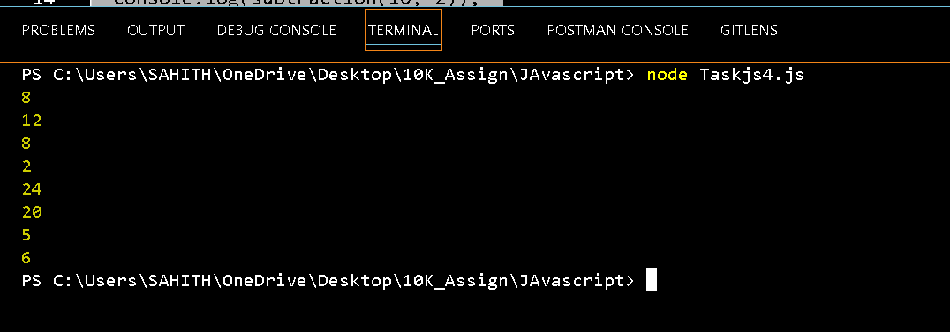

2)Write a JavaScript function that takes a number as a argument and returns it's square value

function squareNumber(number) {

    return number * number;

  }

  // By values:

  let value = 5;

  console.log(squareNumber(value))

**Output:-**

**25**

3 ) 👇👇Write a JavaScript function that takes two numbers as a arguments and returns the highest(max ) of the number using terinary operator inside a function

function getMaxNumber(v1, v2) {

  return v1 > v2 ? v1 : v2;

}

// by values:

console.log(getMaxNumber(5, 10));

console.log(getMaxNumber(20, 5));

**Output:**



4) 👇👇Write a javascript function which takes three arguments (amount , rate of interest, no of years ) returns the total value of interest

function Interest(Pamount, rate, years) {

let totalInt = (Pamount * rate * years) / 100;

 return totalInt;

}

let amount = 1000;

let rate = 5;

let years = 3;

let totalInterest = Interest(amount, rate, years);

console.log(`Total interest for the amount ${totalInterest}.`);

**Output:-**

